[cover sheet]

3

ASSIGNMENT 3

**CYCLOMATIC COMPLEXITY, PHASE 1**

CSE 6329 -- SOFTWARE MEASUREMENT AND QUALITY ENGINEERING

Professor Dennis J. Frailey

**Spring, 2016**

|  |  |
| --- | --- |
| NAME | STUDENT ID NUMBER |
| **SANDEEP YERRAMSETTI** | **1001156902** |

|  |  |  |  |  |
| --- | --- | --- | --- | --- |
| **Cyclomatic Complexity Calculation** | | | | |
| **Program** | **Arcs** | **Nodes** | **Arcs - Nodes** | **Arcs – Nodes + 2 (Cyclomatic Complexity)** |
| Main | 9 | 8 | 1 | 3 |
| Function | 39 | 32 | 7 | 9 |

|  |  |  |  |  |
| --- | --- | --- | --- | --- |
| **Grading Comments (student – do not write inside this box)** | | | | |
| **Phase 1** | | | | |
| **<total goes here>** | **/10** | **Flowgraph (m)** | | **Comments from Grader** |
| **/5** | **Complexity (m)** | |
| **/10** | **Program (f)** | |
| **/10** | **Flowgraph (f)** | |
| **/ 5** | **Complexity (f)** | |
| **Phase 2** | | | | |
| **<total goes here>** | **<name>** | | First Program Reviewed | |
| **/ 5** | | **Errors** |  |
| **/ 5** | | **Cyclomatic Complexity** |
| **/ 10** | | **Flowgraph** |
| **<total goes here>** | **<name>** | | Second Program Reviewed | |
| **/ 5** | | **Errors** |  |
| **/ 5** | | **Cyclomatic Complexity** |
| **/ 10** | | **Flowgraph** |
| **<total goes here>** | **<name>** | | Third Program Reviewed | |
| **/ 5** | | **Errors** |  |
| **/ 5** | | **Cyclomatic Complexity** |
| **/ 10** | | **Flowgraph** |
| **<total>** | **Grand Total** | | |  |

**Place flowgraphs on next page(s)**[cover sheet]

3

ASSIGNMENT 3

**CYCLOMATIC COMPLEXITY, PHASE 2**

CSE 6329 -- SOFTWARE MEASUREMENT AND QUALITY ENGINEERING

Professor Dennis J. Frailey

**Spring, 2016**

|  |  |
| --- | --- |
| NAME | STUDENT ID NUMBER |
| **<your name goes here>** | **<ID number goes here>** |

**Turn this in separately for each program you evaluate!**

|  |  |
| --- | --- |
| **Name of Program Evaluated** | **Discussion of Any Errors Found and How to Correct Them** |
|  | (expand as needed) |

|  |  |  |  |
| --- | --- | --- | --- |
| **Cyclomatic Complexity Calculation** | | | |
| **Arcs** | **Nodes** | **Arcs - Nodes** | **Arcs – Nodes + 2**  **(Cyclomatic Complexity)** |
|  |  |  |  |

**Place flowgraph on next page.**

**Main function FLOWGRAPH:**

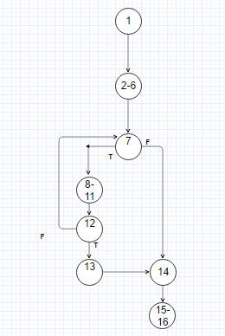

**GPA function flow graph:**

